**A Year of Organic Chemistry Group Work with iPads**

**Abstract**

Collaborative group work is an established means of building active learning into classroom activities. It has been shown to improve the learning gains of students regardless of ability level. This poster describes an effort to incorporate iPads in collaborative group work in a typical year-long organic chemistry course. Audio-visual solutions were developed in groups of 3-4 students, viewed in class, and stored in a course management database for later review. Successes and challenges of this approach will be discussed.

**Introduction**

There are a variety of established methods available to incorporate group work in the chemistry classroom – jigsaw, gallery walk, and think-pair-share being among the most common. These collaborative efforts have been shown to improve student learning, which is naturally the primary reason for their adaption. There are also significant advantages for traditional brick-and-mortar institutions seeking to retain a competitive advantage over online learning opportunities. These include their ability to act as catalysts in the formation of learning communities and their ability to improve students’ ability to work in teams.

The advent of tablet computers and their ready availability introduces a new world of possibilities including the creation of solutions that are animated rather than static. This new ability could place further emphasis upon underlying thought processes, both correct and faulty, than was previously possible. It could also provide opportunity for students to further develop their writing and speaking abilities. Finally, archiving of these animated solutions could provide students additional perspectives to review after class. This poster describes a series of attempts to achieve this ideal in a one-year organic chemistry sequence at a Midwestern liberal arts institution.

**Design**

The group work was implemented in conjunction with a flipped classroom using a hybrid JiTT and video mini-lecture format described elsewhere.1 Class time was split approximately 50-50 between mini-lecture responses to the JiTT question and group work (Figure 1). The *Explain Everything* app2 and Moodle courseware were used throughout the academic year.



**Figure 1** **– Format for in-class collaborative group work.** Class sections varied in size from 24-36 students. Students were allowed to choose their own groups and could rearrange after each exam. Each group of 3-4 students used a numbered iPad with an external microphone and stylus. Participation grades were assigned based upon engagement in the group activities, not the quality of solutions produced.

The first semester, Organic 1, video solutions were viewed from the Moodle database (Figure 2).

[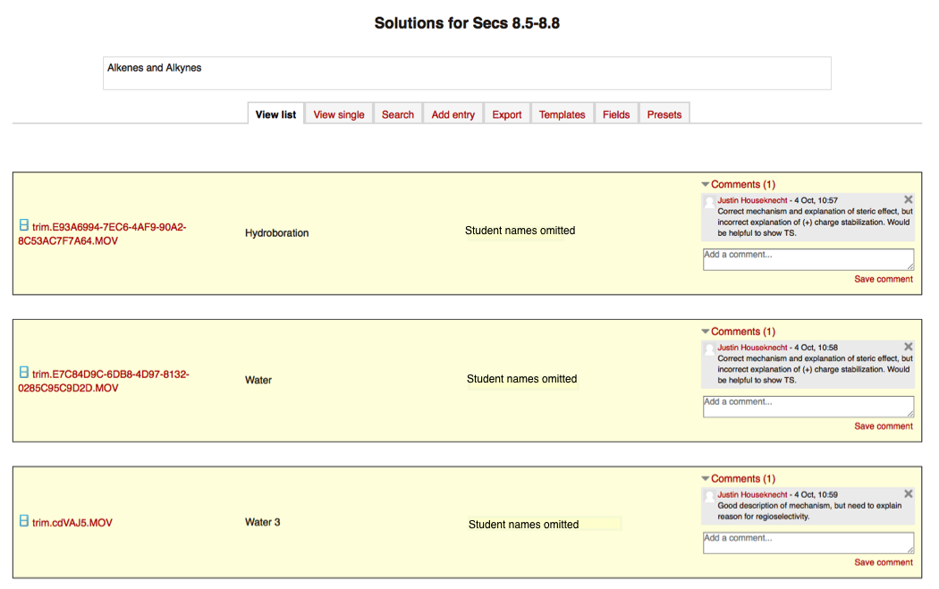](trim.cdVAJ5.MOV)

**Figure 2** **– Typical Moodle database entry from Organic 1.** Students were encouraged to comment upon the strengths and weaknesses of the posted solutions both in class and afterward. It was initially hoped this could be done through an anonymous (to the students) *rate* feature, but was eventually implemented using the *comment* feature that is not anonymous.

The second semester, Organic 2, streamlined the in-class process by viewing video solutions directly from *Explain Everything* by physically connecting the appropriate iPad to the projector input. The groups were encouraged to post their solutions to the Moodle database for points in an extra credit tournament (Figure 3). The postings contained only the group name (e.g., The Halogens, One Proton Short of Mercury) and were thereby somewhat anonymous.

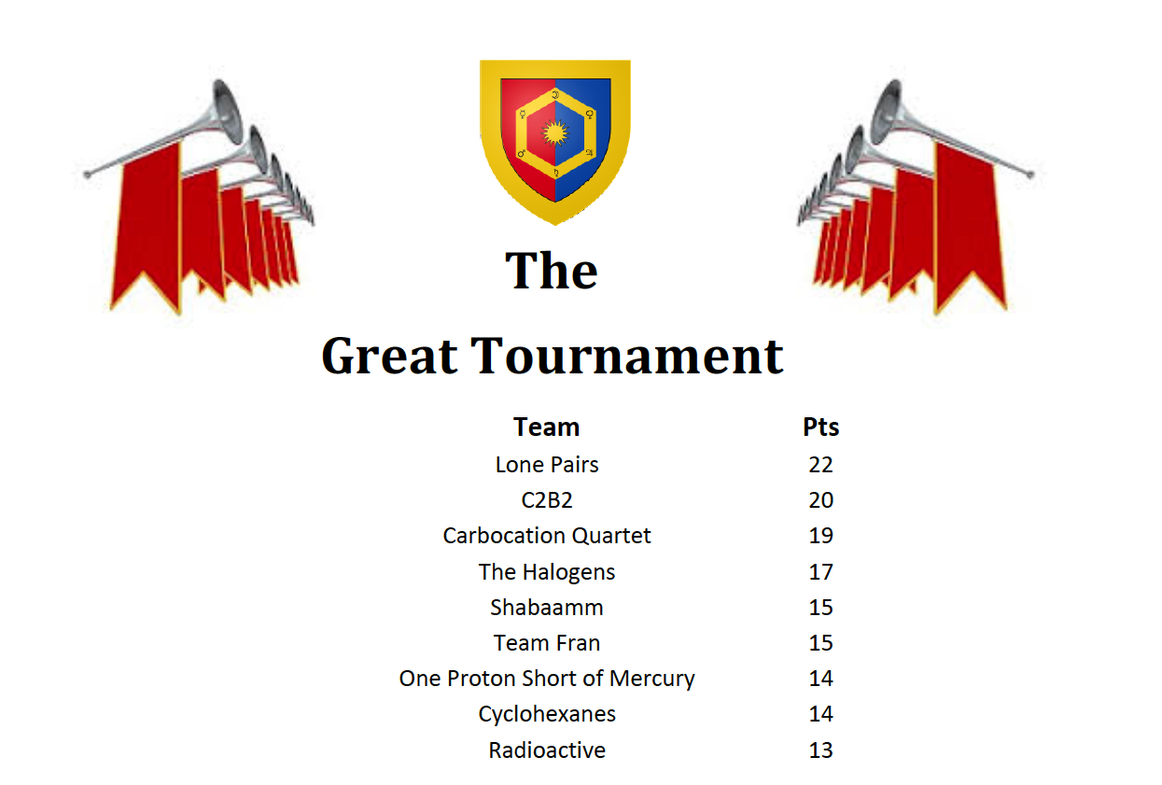

**Figure 3** **– Results of an extra credit tournament.** Points were awarded based upon solution quality (2 = great, 1 = the right idea, 0 = wrong) and clearly indicated in the *comments* section of the database. Teams with the five most points prior to each exam received extra credit points on the exam (5, 4, 3, 2, or 1 depending upon place) with the four lowest-scoring groups receiving no extra credit.

**Results**

*Overall* results were highly encouraging. The groups worked very well despite allowing students to self–assemble their own groups, not forcing rearrangement, and barely assigning group roles. Groups were consistently on-task and students consistently had “aha” moments in class. Nine of sixteen students that responded to the end-of-semester survey commented favorably about group work in the first semester and five of eight in the second semester. One typical response was, “group work time and time again helps out amazingly, especially when you get to look at them and critique it”. The only negative comments about group work (2) were that it took away from lecture time. Exam scores increased by one-half to two-thirds of a letter grade and the first-semester DFW rate fell from a previous 5-year average of 26% to 6%.1 Scores on the cumulative ACS Organic Chemistry exam were similar to previous years, though the presence of serious uncontrolled variables obviated any meaningful statistical analysis.

*The solution database* on Moodle, however, was less successful. Challenges included:

* Too much time was required to convert the video into MOV files within *Explain Everything*
* Too much time was required to upload the MOV files to the Moodle database
* Campus IT and I were unable to get the *rate* feature in Moodle to work correctly
* Students were unwilling to comment electronically upon one another’s work
* Students reported having no confidence in the solutions posted to Moodle unless the instructor commented upon each (first semester)
* Too much time was required for the instructor to comment upon each solution posted to Moodle (both semesters)
* Students reporting having no time to review the solutions posted to Moodle (second semester)

**Discussion and Conclusion**

There were many advantages to the transition from a lecture pedagogy to one based upon active learning in collaborative groups. Arguably the most important and easy to measure was that student success rates increased dramatically as measured by exam scores and DFW rates. It is important to note that learning objectives and assessment methods were held constant through this transition. Use of the *Explain Everything* app had several advantages over traditional group activities involving paper or whiteboards:

* Increased emphasis on the process of problem solving as the media made it easy to explain verbally and in writing how solutions were determined. The process was presented to the class for discussion, not just the solution.
* Students did not suffer from public speaking anxieties even though that is what they were doing. I know from previous experiments that most of my students “freeze up” when asked to explain anything live, yet they quickly became comfortable with this format. The ability to pause, rewind, or completely start over while explaining a solution seemed to be the primary factor. Presumably recorded public speaking is a step toward more effective live public speaking.
* Students effectively critiqued thought processes in class. They were immediately comfortable discussing the strengths and weaknesses of the solutions that we reviewed in class, both their own and others’. As with public speaking anxiety this seemed to be an artifact of the recorded media.

The challenges of this pedagogy could all be solved if humans had more time in each day:

* Preparation for teaching a flipped classroom is more time consuming than preparing lecture notes. Mini-lecture must be recorded, reading guides assembled, JiTT responses incorporated, group problems developed, etc. I hope there are ways to decrease this in the second and third iterations, but it is a reality for the first time teaching a flipped course.
* The solutions database on Moodle was under-utilized. Not even the most motivated students reviewed solutions in the database after class. Many recognized how useful it could be, but reported a lack of time to do so. This is likely a result of many other learning opportunities in the class that were more (or at least sufficiently) effective.

**References**

1. Houseknecht, Justin B., Andrews, Douglas M. “Just-In-Time Teaching of Organic Chemistry Using the *Explain Everything* App.” *Journal of Chemical Education*, submitted.
2. *Explain Everything*, version 2.31, MorrisCooke: Wroclawski, Poland, 2013.